Capstone 33.4 Step 10: Design Your Deployment Solution

Project Components and Architecture

In our financial sentiment analysis project, we leverage GitHub to store our code, Hugging Face to store the trained models to utilize the models for inference, and Streamlit as our frontend and deployment platform. Alternatively, we can utilize Docker Containers and Amazon EC2 or Docker Containers and Amazon ECS Fargate for deployment. Currently I am using Streamlit for deployment but will try the alternatives.

The project started by obtaining data from Hugging Face and Kaggle.
https://huggingface.co/datasets/zeroshot/twitter-financial-news-sentiment
https://www.kaggle.com/datasets/ankurzing/sentiment-analysis-for-financial-news

Then I combined, cleaned up, and prepared the data for use in creating my own models as well as fine-tuning the models for further use. As mentioned before, the models will be stored on Hugging Face and copies of the datasets used will be available on GitHub.

The trained models can make predictions as long as one has an access token and the path of the models. Using the requests library in Python one can call the model APIs from Hugging Face. This is used in my Streamlit app where I call the APIs from Hugging Face to make sentiment predictions on the news headlines to be displayed on my dashboard application.

Ideally, I should be able to grab headlines from news sites and store the business headlines data in .csv files to be used to retrain my model. This is further work to consider. Currently my model has around an 85% chance of predicting correctly on the test data supplied, any improvement beyond that is good to be used as a new model candidate. The retrained model is currently deployed manually. In the future, we can create a Jenkins job to run the retraining of the model and upload it to Hugging Face if the accuracy is better than before. The improved models can be given new names and will be store on Hugging Face as well.

Email and/or Slack messages (or using other messaging apps) can be configured through Jenkins, and if configured or coded we can find out the good and bad of our models. When enough data or after a certain amount of days we can try retraining the model during the nighttime. This will prevent unexpected errors or outages. Jenkins is free to use for job configuration.

Current Deployment Architecture Diagram

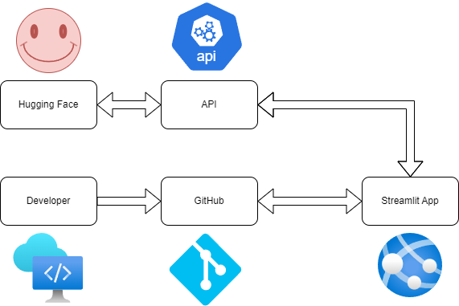

The deployment architecture is simple and good for new users to these technologies. Streamlit makes it easy to create simple applications to showcase your skills.

Cost Estimates
Current Deployment Architecture
- GitHub – Free
- Streamlit App – Free if deployed as a Community User
- Hugging Face – Free
- Hugging Face API – APIs from your own trained models are free, professional trained model APIs cost money

Alternate Deployment Architecture (in addition to above)
- Docker Containers - Free for typical use
- AWS EC2 - Free Tier user (lasts 1 year) using instance t2.micro, 750 Hours per month
- AWS ECS Fargate - Free Tier user (lasts 6 months, 2200 hours per month

Deployment Time - Initially around 10 minutes, updates will take a minute

Pre-Deployment Checklist
- Define the Problem – Sorting the sentiments of Business News into Negative, Positive or Neutral
- Prepare Data – Collect, combine and clean the data for use
- Spot Check Algorithms – Checked test data to see accuracy of predictions
- Improve Results – Tuned the algorithms and retrained the model to perform better
- Present Results – Streamlit app created to showcase sentiment analysis on Business News

The above are all done, but some updates are needed from review from mentor.

